# Determine if the Relation is a Function

$\text{a) }x^{2}+y^{2}=36$ $\text{b) }\{\left(6,1\right), \left(6,2\right), \left(8,3\right), \left(9,4\right)\}$

c)

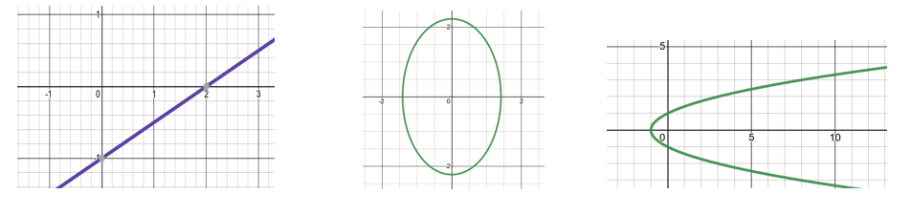

# Interpret a Function in Context

The table shows the chances (as a percent) of an adult surviving to various ages after reaching 60 years old in a particular country. One model that fits the data is the function $g\left(x\right)=-2.9x+287$

| Age | 70 | 80 | 90 | 100 |
| --- | --- | --- | --- | --- |
| Chance of Survival | 85 | 58 | 24 | 2.7 |

What do the variables $x$ and $g(x)$ represent? Use the model to evaluate $g(80)$ and interpret its meaning in a sentence. How does it compare to the actual value from the data set?

# Find the Domain/Range, Intercepts, and Interval(s) Where the Function Increases/Decreases, and Extrema.

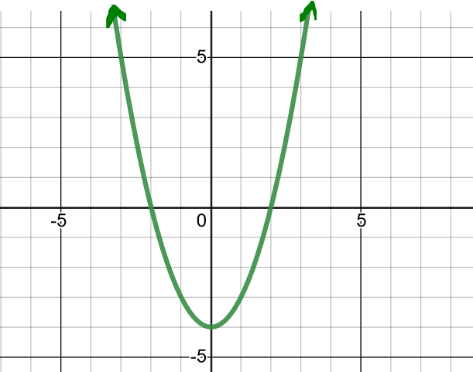

Is the graph symmetrical across the x-axis, y-axis, or origin?

Is the function even, odd, or neither?

# Write a linear equation

a) A company that manufactures bicycles has a fixed cost of $100,000. It costs $100 to produce each bicycle. The total cost for the company is the sum of its fixed cost and variable costs. Write the total cost, *C,* as a function of the number of bicycles produce, *x*. Then find and interpret *C(90).*

# Evaluate the Piecewise Function



a) *f(-3)* b) *f(0)* c) *f(4)*

# Find the Equation of the Line

a) Parallel to the line $y=2x$ that passes through the point $\left(1,-3\right)$

b) Perpendicular to the line $y=2x$ that passes through the point $\left(2,-1\right)$

c) Whose graph follows:

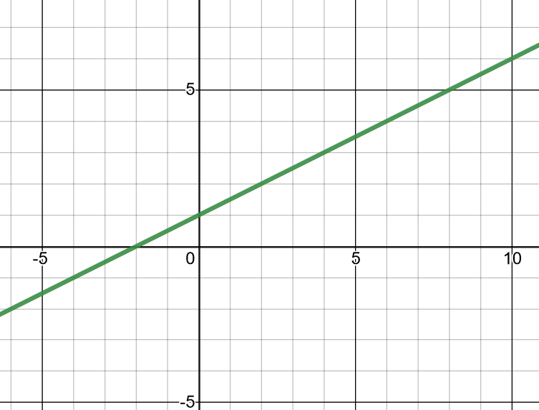

d. Parallel to the line with a slope of 0 going through the point (4, -7).

# Find the Average Rate of Change

The age (in years) and expected length (in inches) of certain species of fish is modeled by the function: $f\left(x\right)=0.016x^{3}-0.372x^{2}+3.95x+1.21$; find the average rate of change in expected length between a fish at 10 and 15 years. Include units. Interpret your answer in a sentence.

# Construct and Simplify the Difference Quotient

a) $f\left(x\right)=3x+7$ b) $g\left(x\right)=7x^{2}-2$

# Find the Domain of the Function

a) $h\left(x\right)=\sqrt{3x-2}$ $\text{b) }g\left(x\right)=\frac{1}{4x-3}$ c. $f\left(x\right)=8x-1$

# Compose the Functions

Let $f\left(x\right)=3x-4$ and $g\left(x\right)=x^{2}+6x$



a) Find $\left(f∘g\right)\left(x\right)$ b) Find $\left(g∘f\right)\left(x\right)$ c) Find $\left(g∘f\right)\left(3\right)$

# Decompose the Function so $h\left(x\right)=(f∘g)(x)$. Report f(x) and g(x).

a) $h\left(x\right)=\sqrt[3]{5-x^{8}}$ $\text{b) }h\left(x\right)=\frac{1}{5x+6}$

# Find the Inverse for the 1:1 Function and its domain

a) $f\left(x\right)=2x-1$ b) 